Multihull - Accessories

**Cross Beam**

Vertical distance from FS chain plate to XB240 crossbeam bracket upper hole = 67 mm

Horizontal distance from FS chain plate to XB240 crossbeam bracket upper forward hole = 93mm.

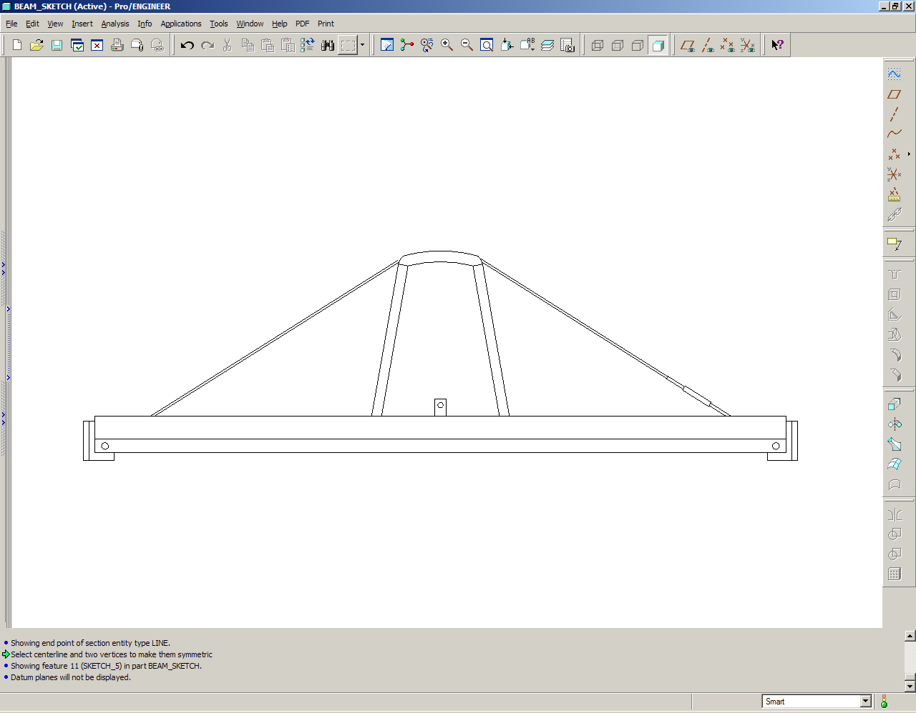

Total Crossbeam length including chainplate brackets

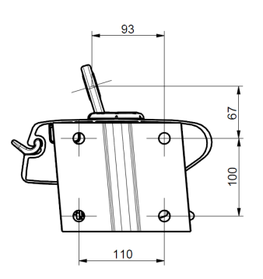

|  |  |
| --- | --- |
|  | mm |

|  |  |  |
| --- | --- | --- |
| Cross beam be supported by compression beam: | Yes | No |

**Bow Sprit**

DTF (Distance to fore stay)

Lat.

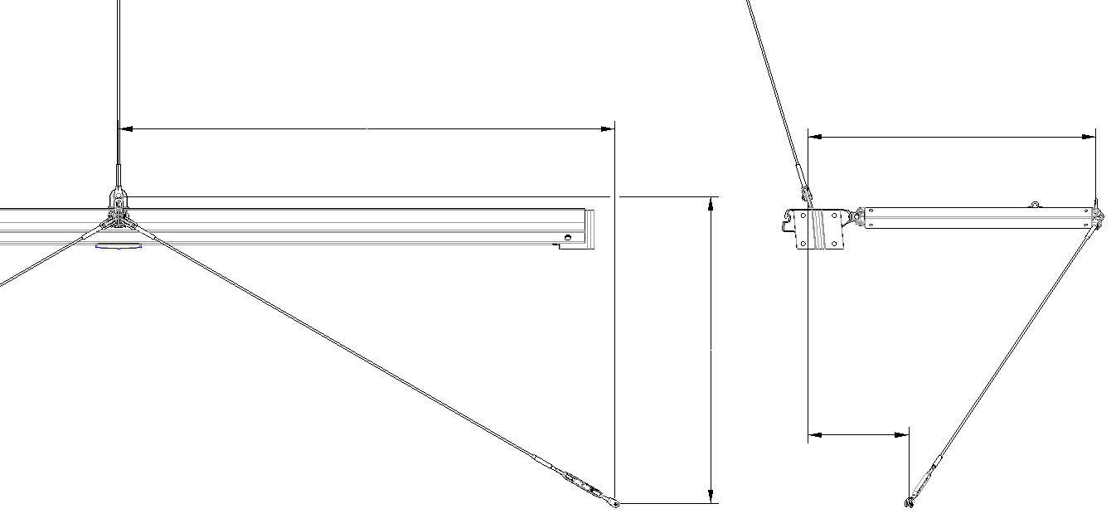

Geometry for bow sprit:

All measures are in reference to the fore stay chain plate

|  |  |  |
| --- | --- | --- |
| **Bow sprit** | |  |
| DTF |  | mm |
| Lat. |  | mm |
| Long. |  | mm |
| Vert. |  | mm |

Vert.

Long.

|  |  |  |  |  |  |
| --- | --- | --- | --- | --- | --- |
| Cross beam be supported by compression beam: | | Yes | | No | |
|  | |  | |  | |
| Bow sprit to be used for code zero:  *See 595-718 for definitions* | | Yes | | No | |
|  | |  | |  | |

|  |
| --- |
| Comments:  ……………………………………………………………………………….………………………………………………………………...……………………………….…………………………………………………………….………………………………………………………………...……………………………….…………………………………………………………….………………………………………………………………...……………………………….…………………………………………………………….………………………………………………………………...……………………………….……… |
|  |

*Selden internal notes:*

*Selection guide is found in MB MH 01 & MB MH 02.*

10667_selden