595-776-E

14-04-28

1(3)

Correct information – Correct rig

Multihull

Spars and rigging are the most exposed parts of a sailing craft. Safety on board and performance puts high demands on strength and functional design. Our technical knowledge and long experience guarantee the quality but, to make everything suit your craft, we are completely dependent on the information you give us.  
To make it possible for our designers to provide you with the best rig, we need the following information about your craft:

For definitions of measures, please see "Seldén definitions - Rig fact measures", 595-566.

Seldén has chosen four standard setups:

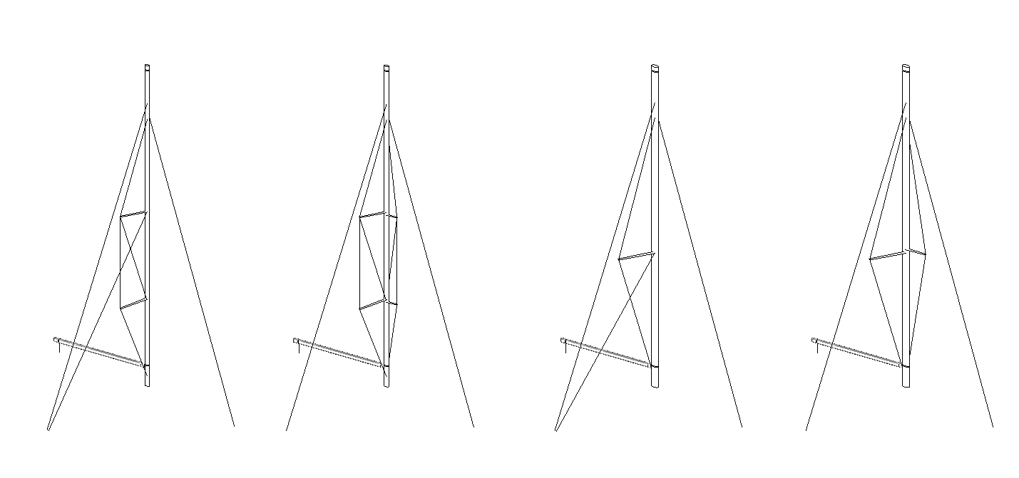

Double diamonds with lower shrouds

Single diamond with lower shrouds

Single diamond no lower shrouds, forward strut may be needed

Double diamonds no lower shrouds, forward struts needed.

**Rig setup and dimensioning**Please fill the forms **”Rig Setup”** and **“Craft Data”** on page 2 for a rig dimensioning.  
(A drawing/sailplan of the requested rig setup is desirable).

**Standing rigging lengths**If standing rigging with swaged ends is requested, we can calculate the lengths based on information given by you. Please fill the form ”**Chainplates”** on page 3.

We thank you, in advance, for your cooperation.

Yours sincerely

**Seldén Mast AB**

***10667_selden***

*www.seldenmast.com*

|  |  |
| --- | --- |
| ***Sweden:*** *Seldén Mast AB • Tel: +46 (0)31 69 69 00 • info@seldenmast.com* | ***Denmark:*** *Seldén Mast A/S • Tel: +45 39 18 44 00 • info@seldenmast.dk* |
| ***UK:*** *Seldén Mast Ltd. • Tel: +44 (0)1329 50 40 00 • info@seldenmast.co.uk* | ***The Nether­lands:*** *Seldén Mid Europe B.V. • Tel: +31 (0)111-698 120 • info@seldenmast.nl* |
| ***USA:*** *Seldén Mast Inc. • Tel: +1 843-760-6278 • info@seldenus.com* | ***France:*** *Seldén Mast SAS • Tel: 33 (0) 251 362 110 • info@seldenmast.fr* |  |
| *Seldén and Furlex are registered trademarks of Seldén Mast AB* | |

|  |  |
| --- | --- |
| *Seldén’s notes* | 595-776-E  14-04-28  2(3) |
| Rig data no. | M |
| Sales manager |  |

**Rig facts, Multihull yachts**

**Information required for calculation of spars and standing rigging.**

|  |  |  |  |  |  |  |  |  |  |  |  |  |  |  |  |  |  |
| --- | --- | --- | --- | --- | --- | --- | --- | --- | --- | --- | --- | --- | --- | --- | --- | --- | --- |
| |  |  |  |  |  | | --- | --- | --- | --- | --- | |  | Yacht: |  | | | |  | Customer: |  | | | |  | Telephone: |  | E-mail: |  |   For definitions of measures, please see "Seldén definitions - Rig fact measures", 595-566. | | |
| **Rig Setup** |  | |
| |  |  | | --- | --- | |  | Double diamonds with lower shrouds | |  | Double diamonds no lower shrouds, forward struts needed. | |  | Single diamond with lower shrouds | |  | Single diamond no lower shrouds, forward strut may be needed. | |  | | |  | Other:  ........................................................................................................................................ |   C-C Hulls  Lower  Shroud  (LWR)  Cap  Shroud  (CAP)  Craft centre line  Mast  Fore Stay  (FS)  Cutter Stay  (CS) | |  |  |  |  |  |  |  |  |  |  | | --- | --- | --- | --- | --- | --- | --- | --- | --- | --- | |  | Conventional mast | | |  | | Carbon mast |  | Tapered mast | | |  |  | | |  | |  |  |  | | |  | |  | | | | |  | | |  | Standard roach | |  | | Medium roach | |  | Square roach | | | Other rigging particulars: | | | | | | | | | | | ……………………………………………………………………………….…………………………………………………………………………………………….……… | | | | | | | | | | | |
| |  |  |  |  |  | | --- | --- | --- | --- | --- | | Forestay height | FH | = |  | mm | | Cutter stay height | CSH | = |  | mm | | Main sail luff length | P | = |  | mm | | Boom height (top of boom) | BH | = |  | mm | | Main sail foot length | E | = |  | mm | | Main sheet distance from aft face of mast | S | = |  | mm | | Coach roof height above cap-chainplate | DH | = |  | mm | | Coach roof height above waterline | WLH | = |  | mm | | |
| |  |  |  | | --- | --- | --- | |  | Lateral | Longitudinal | | CAP\* |  |  | mm | | LWR |  |  | mm | | FS |  |  | mm | | CS |  |  | mm | | \*Cap shroud bridle chainplates | | |  | | Forw. |  |  | mm | | Aft |  |  | mm |   Chainplates  \*If cap shroud bridle is to be used, please state bridle chainplate positions. | |
| |  |  |  |  |  |  |  |  |  |  |  |  |  |  |  |  |  |  | | --- | --- | --- | --- | --- | --- | --- | --- | --- | --- | --- | --- | --- | --- | --- | --- | --- | --- | | **Craft Data** | | | | | | | | | | | | |  | |  | |  | |  | Catamaran | | Windward hull to be flown above the water: | | | | | | Yes | | No | | | |  | Trimaran | | Trimaran outer pontoon volume: | | | | | |  | | litres | | | |  | | | | | | | | | | | | | | | | | | | Length over all | |  | | mm | Max beam |  | | mm | | C – C Hulls | | |  | | | mm | | |  | |  | |  |  |  | |  | |  | | |  | | |  | | | Displacement | |  | | kg | Displacement valid for: | | Yacht empty | | | | | Yacht equipped | | | | | | | |
|  |  |
| |  |  |  | | --- | --- | --- | | **Please check and sign this form and return it to Seldén.** | | | |  |  |  | | Signature, order only | Block letters | Date | | remark: Chain plate heights, cross beam and bow sprit measurements, please see overleaf. | | |   **10667_selden** | |

|  |  |
| --- | --- |
| *Seldén’s notes* | 595-776-E  14-04-28  3(3) |
| Rig data no. | M |
| Sales manager |  |

**Rig facts, Multihull yachts**

**Chainplates**

|  |  |  |  |  |
| --- | --- | --- | --- | --- |
|  | Yacht: |  | | |
| Customer: |  | | |
| Telephone: |  | E-mail: |  |

**Chainplates**

All measures to centre of symbol

Chainplate **below** coach roof “+”

Chainplate **above** coach roof “-”

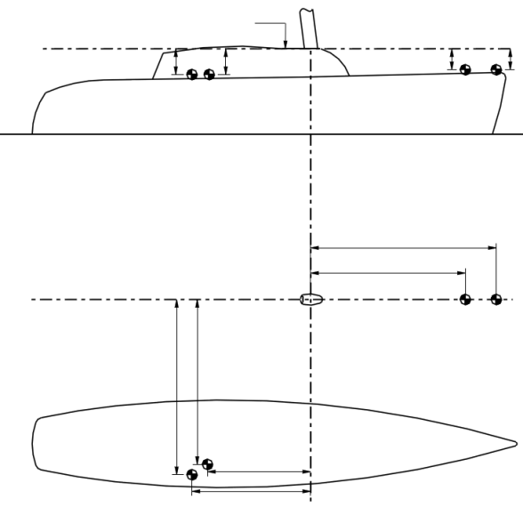

CAP

LWR

CS

FS

Lower

Shroud

(LWR)

Cap

Shroud

(CAP)

Craft centre line

Top of coach roof

Mast

Fore Stay

(FS)

Cutter Stay

(CS)

Ø

|  |  |  |  |  |  |  |  |
| --- | --- | --- | --- | --- | --- | --- | --- |
| Mast rake (degrees) | |  | ° |  | | |  |
|  | |  |  |  | | |  |
|  | Lateral | Longitudinal | Vertical | Ø | | |  |
| CAP\* |  |  |  | |  | | mm |
| LWR |  |  |  | |  | | mm |
| FS |  |  |  | |  | | mm |
| CS |  |  |  | |  | | mm |
|  | |  |  | | --- | --- | | \*Cap shroud bridle chainplates |  | | | | | | |  |
| Forw. |  |  |  | | mm |  | |
| Aft |  |  |  | | mm |  | |
|  |  |  |  | |  |  | |
|  |  |  |  | |  |  | |
| Other chainplates particulars | | | | | | | |
| ……………………………………………………………………………….………………………………………………………………...……………………………….………………………………………...... | | | | | | | |

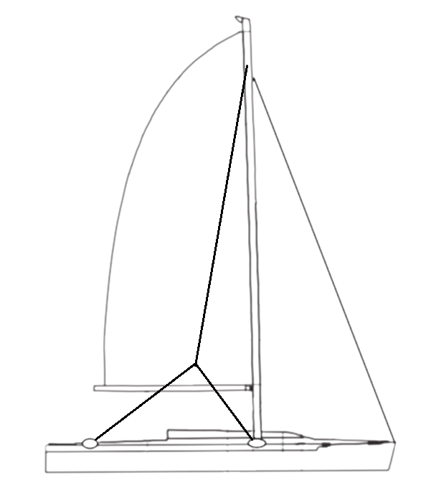

\*If cap shroud bridle is to be used, please state bridle chainplate positions.

|  |  |  |
| --- | --- | --- |
| **Please check and sign this form and return it to Seldén.** | | |
|  |  |  |
| Signature, order only | Block letters | Date |

10667_selden