595-543-E

12-07-03

1(3)

Correct information – Correct rig

Spars and rigging are the most exposed parts of a sailing yacht. Safety on board and   
performance puts high demands on strength and functional design. Our technical   
knowledge and long experience guarantee the quality but, to make everything suit   
your boat, we are completely dependant on the information you give us. To make it   
possible for our designers to provide you with the best rig, we need the following   
information about your boat:

For definitions of measures, please see "Seldén definitions - Rig fact measures", 595-566.

**1. Hull and spars.** Enclosed form **”Rig facts”** filled in (a drawing of the rig is

desirable).

The distance from the top of the keelson to the top of the coach roof, where the mast

passes through the deck, is important, so that internal and external sealings and other

fittings can be fitted in their correct positions in relation to the deck.

This dimension (denoted ”Q” on **”Rig facts”**) must therefore be stated. You can not

measure the dimension on the drawing as it almost always differs from the actual

dimension on the hull. You should note that there can be considerable differences if the

measurement is taken with the yacht resting on its keel or floating in the water. Q is less

when the yacht is resting on its keel.

**2. Standing rigging.** Our experience has taught us that the drawing can not provide

accurate measurements.

We can calculate the lengths based on information given by you, on the form

**”Chainplates”**.

Information given by phone must be confirmed by letter, fax or e-mail, in order to avoid any

misunderstanding.

We thank you, in advance, for your cooperation.

Yours sincerely

**Seldén Mast AB**



*www.seldenmast.com*

|  |  |
| --- | --- |
| ***Sweden:*** *Seldén Mast AB • Tel: +46 (0)31 69 69 00 • info@seldenmast.com* | ***Denmark:*** *Seldén Mast A/S • Tel: +45 39 18 44 00 • info@seldenmast.dk* |
| ***UK:*** *Seldén Mast Ltd. • Tel: +44 (0)1329 50 40 00 • info@seldenmast.co.uk* | ***The Nether­lands:*** *Seldén Mid Europe B.V. • Tel: +31 (0)111-698 120 • info@seldenmast.nl* |
| ***USA:*** *Seldén Mast Inc. • Tel: +1 843-760-6278 • info@seldenus.com* | ***France:*** *Seldén Mast SAS • Tel: 33 (0) 251 362 110 • info@seldenmast.fr* |  |
| *Seldén and Furlex are registered trademarks of Seldén Mast AB* | |

|  |  |
| --- | --- |
| *Seldén’s notes* | 595-543-E  12-07-02  2(3) |
| Rig data no. |  |
| Sales manager |  |
|  |  |
|  |  |

**Rig facts**

**Information required for calculation of spars and standing rigging.**

|  |  |  |  |  |  |  |  |  |  |  |  |  |  |  |  |  |  |  |  |  |  |  |  |  |  |  |  |  |  |
| --- | --- | --- | --- | --- | --- | --- | --- | --- | --- | --- | --- | --- | --- | --- | --- | --- | --- | --- | --- | --- | --- | --- | --- | --- | --- | --- | --- | --- | --- |
| |  |  |  |  |  |  |  |  |  | | --- | --- | --- | --- | --- | --- | --- | --- | --- | | **A.** | Yacht: |  | | | Customer: | |  | | |  | Address: |  | | | | | | | |  | Telephone: |  | Fax: |  | | E-mail: | |  |   *For definitions of measures, please see "Seldén definitions - Rig fact measures", 595-566. | | |
| **B. Rig**  **J**  Cap shroud  (V1)  Forward lower shroud  (D1F)  Aft lower shroud  (D1A)  Cutter Stay  (CS)  Baby/inner forestay  (BS/IF)  Lat  Long  Mast  Yacht | |  |  |  |  |  |  |  |  |  | | --- | --- | --- | --- | --- | --- | --- | --- | --- | |  | Masthead | |  | Carbon mast | |  | Sets of spreaders 1, 2, 3 | | |  | Fractional | |  | Conventional mast | |  | Furlex jib furling system | | |  | Deckstepped | |  | In-mast furling mast | |  | Top mast spin | | |  | Keelstepped | |  |  | |  | Tapered mast | | |  | |  | | |  |  | | | Other rigging particulars: | | | | | | | | | | ……………………………………………………………………………….……………………………………………………………………………………….……… | | | | | | | | | | |
| |  |  |  |  |  | | --- | --- | --- | --- | --- | | Forestay height | FH | = |  | mm | | Cutter stay height | CSH | = |  | mm | | Main sail luff length | P | = |  | mm | | Boom height (top of boom) | BH | = |  | mm | | Bury | Q | = |  | mm | | Main sail foot length | E | = |  | mm | | Main sheet distance from aft face of mast | S | = |  | mm | | Forestay chainplate infront of mast. | J | = |  | mm | | Spinnaker pole length | SPL | = |  | mm | | Coach roof height above cap-chainplate | DH | = |  | mm | | Coach roof height above waterline | WLH | = |  | mm | | |
| Location of chainplates   |  |  |  |  | | --- | --- | --- | --- | |  | Lat | Long |  | | V1 |  |  | mm | | D1A |  |  | mm | | D1F |  |  | mm | | BS/IF |  |  | mm | | CS |  |  | mm | | |
| |  |  |  |  |  |  |  |  | | --- | --- | --- | --- | --- | --- | --- | --- | | **C. Righting moment (RM)** | | | | | | | | | **Alt. 1** RM acc. To IMS 1º/20º/40º (IORº) | | | | | |  | kNm | |  | | | | | |  |  | | **Alt. 2** RM at 3**0º** | |  | | kNm (  Seldén heeling test / | | | | |  | |  | | designers) | | | | | Given RM includes | | | | | | | | |  | Yacht empty | |  | | Crew members on rail | | | |  | Yacht equipped | |  | |  | | | | | |  |  |  |  |  |  |  |  |  |  | | --- | --- | --- | --- | --- | --- | --- | --- | --- | --- | |  | | | | | | | | | | | **Alt. 3** The righting moment can be approximately estimated if the following information is given: | | | | | | | | | | |  | Yacht empty | |  | Yacht equipped | | | | | | | Length over all | |  | | | mm | Displacement | |  | kg | | Max beam | |  | | | mm | Ballast | |  | kg | | Draft | |  | | | mm |  | Bulb/Wing keel | | | | Centerboard draft board up/down | | | | | | / | | | | | Ballast board/other | | | | | | / | | | | |
|  |  | |
| |  |  |  | | --- | --- | --- | | **Please check and sign this form and return it to Seldén.** | | | |  |  |  | | Signature, order only | Blockletters | Date | | Remark: Measurement on which calculation of **lengths of standing rigging** shall be based, see overleaf. | | | | | |



**Chainplates**

595-543-E

12-07-02

3(3)

Use “mm”

Chainplate **below** coach roof “+”

Chainplate **above** coach roof “-”

|  |  |
| --- | --- |
| Yacht: |  |
| Owner: |  |

*For definitions of measures, please see "Seldén   
definitions - Rig fact measures", 595-566.

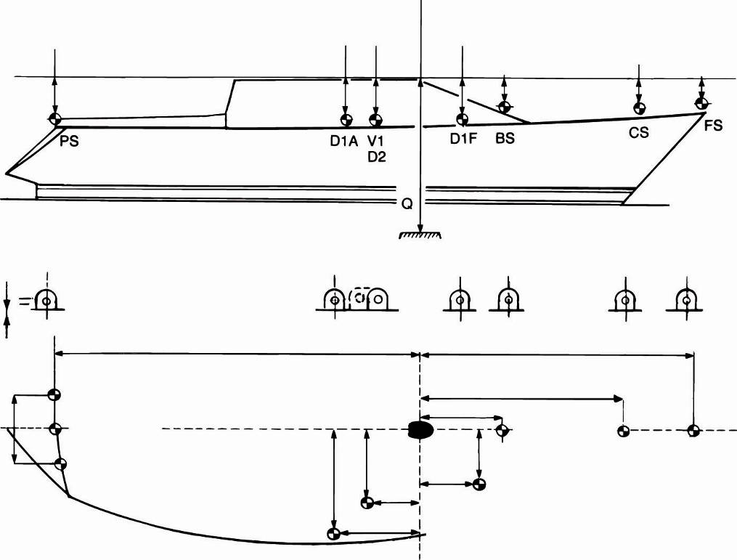

Top of coach roof

Top of keelson

After lower shroud

(D1A)

Back stay

(PS)

Forward lower shroud

(D1F)

Baby/Inner fore stay

(BS/IF)

Cutter stay

(CS)

Fore stay

(FS)

Long

Long

Lat



Cap

shroud

(V1)

Geometric centre of mast

All measure to centre of symbol

**DECK TIPCUP**

**–**

H1

H2

H3

Thread

**CONV. CHAINPLATE**

Ø

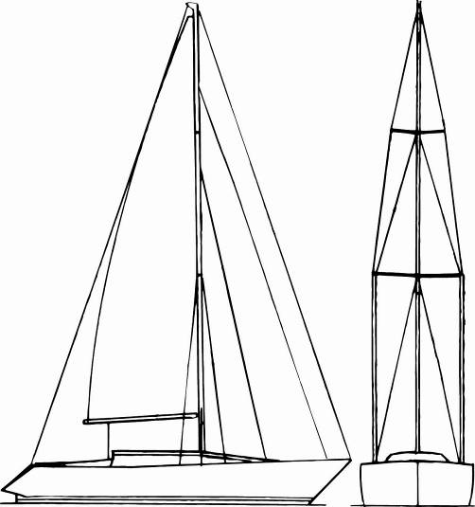

PS

FS

CS

D2

V1

D1A, D1F

BS/IF

D1F

D1A

|  |  |  |  |  |  |  |  |
| --- | --- | --- | --- | --- | --- | --- | --- |
| Mast rake: | | | Q: |  | | | (mm) |
|  | | | | | | | |
| **CHAINPLATE (mm)** | | | | | | | |
|  | **Lat.** | **Long.** | | | **Vert.** | **Ø** | |
| **V1** |  |  | | |  |  | |
| **D1A** |  |  | | |  |  | |
| **D1F** |  |  | | |  |  | |
| **BS/IF** |  |  | | |  |  | |
| **CS** |  |  | | |  |  | |
| **FS** |  |  | | |  |  | |
| **PS** |  |  | | |  |  | |
|  |  |  | | |  |  | |
| **DECK TIPCUP (mm)** | | | | | | | |
|  | **H1** | **H2** | | | **H3** | **Thread** | |
| **V1** |  |  | | |  |  | |
| **D1** |  |  | | |  |  | |
| **D1F** |  |  | | |  |  | |

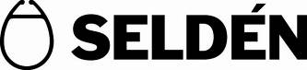

|  |  |  |
| --- | --- | --- |
| **Please check and sign this form and return it to Seldén.** | | |
|  |  |  |
| Signature, order only | Blockletters | Date |